**Photoshop**

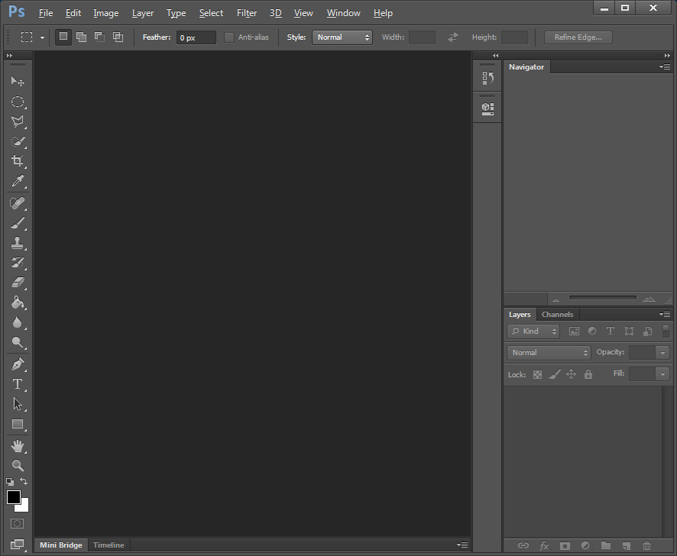

Navigator Pane

Layers Pane

Workspace

Toolbox

**Windows Menu**

|  |  |
| --- | --- |
|  | If the **Toolbox**, **Navigation Pane** or **Layers Pane** is hidden select the **Windows** in the menu bar and click (tick) the required windows. |

**The Photoshop Toolbox**

|  |  |  |
| --- | --- | --- |
| 12  11  10  9  8  7  6  5  4  3  2  1 | 1  Move Tool (V) | 2 |
| 3 | 4 |
| 5 | 6 |
| 7 | 8 |
| 9 | 10 |
| 11 | 12 |

**The Photoshop Toolbox (continued)**

|  |  |  |
| --- | --- | --- |
| 14  13  23  22  21  20  19  18  17  16  15 | 13 | 14 |
| 15 | 16 |
| 17 | 18 |
| 19 | 20  Zoom Tool (Z) |
| 21  Set Foreground Colour  Set Background Colour | 22  Edit in Quick Mask Mode (Q) |
| 23 |  |

**Exercise 01 – Getting Started**

|  |  |  |  |
| --- | --- | --- | --- |
| **Step 1** - Create an image 500 pixels x 500 pixels  To create a new image, select **File** in the menu bar, then **New** from the dropdown menu. |  | |  |
| **Step 2** – The **Brush** **Tool**  Select the **Brush Tool**. Select a brush type and size and paint a squiggly line  Why is the colour of the paint black?  Because this is your foreground colour. | Foreground |  | |

|  |  |  |
| --- | --- | --- |
| **Step 3** - The **Brush** **Tool** (Cont)  Select at least 2 more brush types and continue painting. |  | If you make a mistake, you can go back 1 step, using the **Ctrl** + **Z** keys.  To go back more than 1 step press **Ctrl** + **Alt** + **Z** keys. |
| **Step 4** - **Zooming**  Zoom into your image using the drag selector in the Navigator Pane.  Once you have zoomed in, use the drag the box to navigate your image. | Drag and Drop Box  Whatever is displayed in the drag and drop box is displayed in your workspace. | |
| **Step 5** - Delete  Delete your masterpiece and return to the background colour.  To delete use the **Ctrl** + **A** keys to select all, then press the **Delete** key. | Make sure you select **Background Colour** before clicking the **OK** button. | |

**Exercise 02 – Practice your Skills**

* Change the **Foreground and Background** colours of your image with colours of your choice.
* To change colours click on the foreground colour and select a desired colour from the **Colour Picker** window. Repeat this for the background colour.

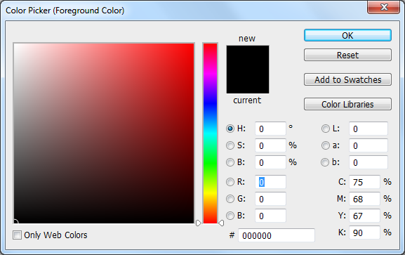

* Use the **Brush Tool** with different brush types and sizes and create another masterpiece.
* Use the **Eraser Tool** to erase a part of anything you have brushed onto your image.
* Save your masterpiece for the Web, your lecturer will explain this process of saving an image for the Web.

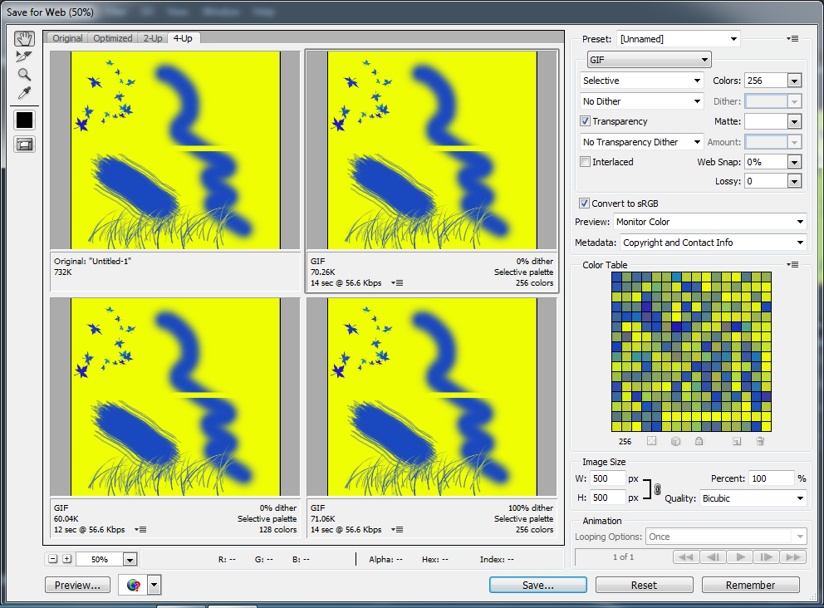

**Exercise 03 – The Marquee Tools**

Create a new image 500 pixels x 500 pixels. Select a blue as the foreground colour and a yellow as the background colour.

|  |  |
| --- | --- |
| **Step 1** - Using the **Rectangular Marquee Tool**, create a rectangular shape on your image. | **Step 2** - Using the **Paint Bucket Tool**, paint your shape blue (the foreground colour). |
| **Step 3** - Invert your selection using **Ctrl** + **Shift** + **I** keys. You will notice the remaining image is now selected. | **Step 4** - Switch the foreground and background colours and paint the inverted selection yellow.  Click to switch      Use the **Ctrl** + **D** keys to deselect your image. Do not save this image. |

**Exercise 03 (Continued)**

|  |  |
| --- | --- |
| Using the **Rectangular Marquee Tool**, attempt to create the following shape. Hint the **Shift** key allows you to add.  If you wish to create a perfect square, hold the **Shift** key whist creating your square with the **Rectangular Marquee Tool**. | Using the **Paint Bucket Tool**, paint your shape. |
| Create the following shape using the **Rectangular Marquee** and the **Elliptical Marquee Tools**.    If you wish to create a perfect circle, hold the **Shift** key whist creating your circle with the **Elliptical Marquee Tool**. | Create the following using with different colours. |

**Exercise 03 (Continued)**

|  |  |
| --- | --- |
| Create the following using **Elliptical Marquee Tool**. Hint **Alt** key allows you to remove. | Create the following using the **Rectangular Marquee** and the **Elliptical Marquee Tools**. |

**Exercise 04 - Photoshop Layers**

A layer is one image stacked on top of another. Layers are used to build images.

|  |  |  |  |
| --- | --- | --- | --- |
| **Step 1**  Create an image 500 pixels x 500 pixels.  Create 3 layers. Accept the default layer names for now.  To create a layer select **Layer** in the menu bar, then **New** from the dropdown menu, and finally **Layer** from the **New** sub-menu. |  |  | |
| **Step 2**  Select Layer 1. Using the **Rectangular Marquee Tool** create a square object and colour it red.  Select Layer 2. Using the **Elliptical Marquee Tool** creates a round object and colour it green.  Select Layer 3. Using the **Polygonal Lasso Tool** creates a triangle object and colour it yellow. | Layer 1 | | Layer 2 |
| Layer 3 | | 1  2    3  Hint, to create a triangle using the **Polygonal Lasso Tool**:   1. Click your mouse to commence. 2. Move to position 2 and click. 3. Move to position 3 and click. 4. Move back to position 1 and click. |

**Exercise 04 (Continued)**

|  |  |  |
| --- | --- | --- |
| **Step 3**  Rename your layers with appropriate names.  To rename a layer, double-click on the layer name and rename it. |  | Rename Layers:   * layer 1 Square * Layer 2 Circle * Layer 3 Triangle |
| **Step 4**  Layers can be visible or hidden.  Click the appropriate show / hide buttons to hide the Square and Triangle layers.  Unhide both layers again. | Show / hide button | |

**Exercise 04 (Continued)**

|  |  |
| --- | --- |
| **Step 5**  Layers can be stacked into different poisons using the drag and drop feature. | Drag and drop |
| Position the square to the top of the stack.  Position the triangle to the bottom of the stack. |  |

**Exercise 04 (Continued)**

|  |  |
| --- | --- |
| **Step 6**  An object within a layer can be moved into different positions within its layer using the **Move Tool**.  Restack your layers and attempt to create the result illustrated. |  |